**Homework lecture 1**

**Sort**

1. Given a list of integer numbers: 2, 1, 10, 6, 3, 8, 7, 13, 20. Draw the steps to sort (ascending sort) the list by following methods:

* Selection sort, Insertion sort

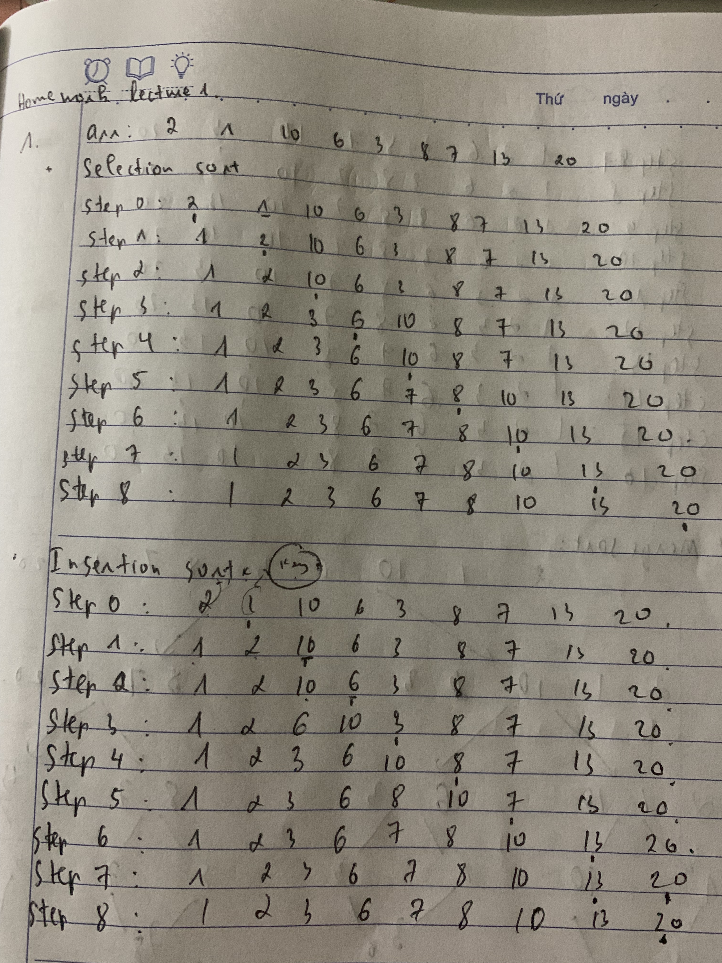

* Bubble sort

Step 0: 2 1 10 6 3 8 7 13 20

Step 1: 1 2 6 3 8 7 10 13 20

Step 2: 1 2 3 6 7 8 10 13 20

Step 3: 1 2 3 6 7 8 10 13 20

Step 4: 1 2 3 6 7 8 10 13 20

Step 5: 1 2 3 6 7 8 10 13 20

Step 6: 1 2 3 6 7 8 10 13 20

Step 7: 1 2 3 6 7 8 10 13 20

Step 8: 1 2 3 6 7 8 10 13 20

1 2 3 6 7 8 10 13 20

* Merge sort

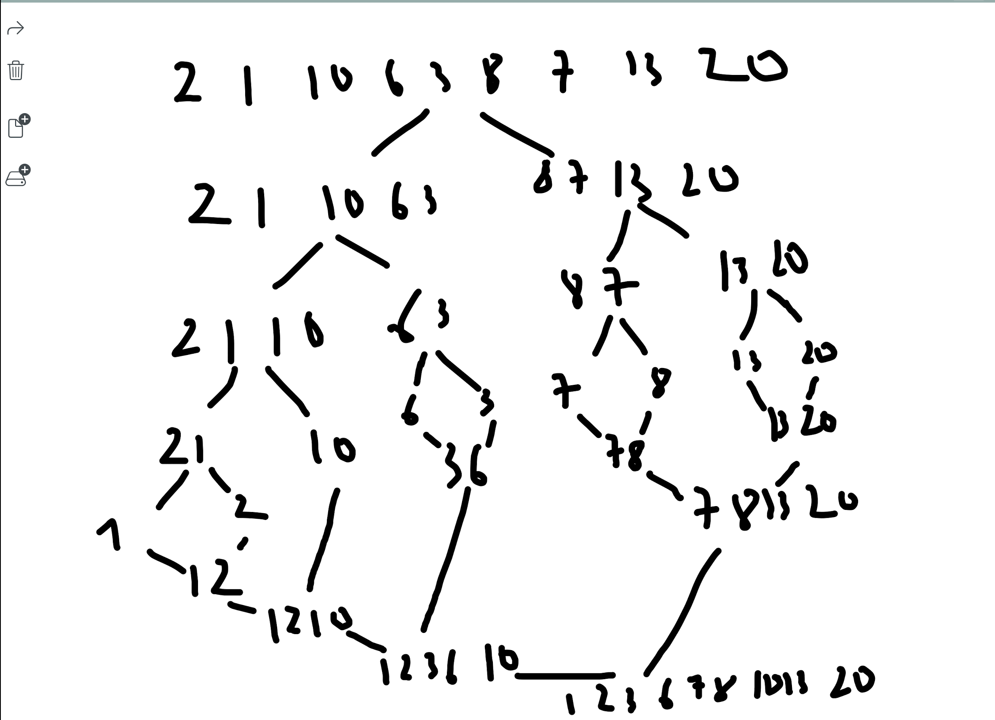

* Quick sort

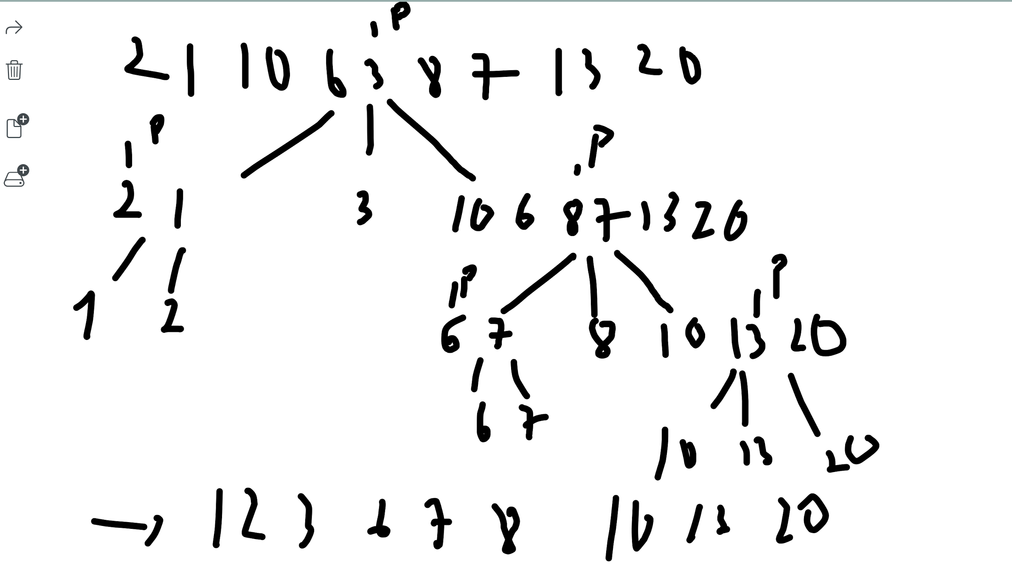

* Heap sort
* Radix sort

1. Same question for these lists:

1, 2, 3, 4, 5, 6, 7, 8, 9, 10

* SelectionSort:

Step 0: 1 2 3 4 5 6 7 8 9 10

Step 1: 1 2 3 4 5 6 7 8 9 10

Step 2: 1 2 3 4 5 6 7 8 9 10

Step 3: 1 2 3 4 5 6 7 8 9 10

Step 4: 1 2 3 4 5 6 7 8 9 10

Step 5: 1 2 3 4 5 6 7 8 9 10

Step 6: 1 2 3 4 5 6 7 8 9 10

Step 7: 1 2 3 4 5 6 7 8 9 10

Step 8: 1 2 3 4 5 6 7 8 9 10

1 2 3 4 5 6 7 8 9 10

* InsertionSort:

Step 0: 1 2 3 4 5 6 7 8 9 10

Step 1: 1 2 3 4 5 6 7 8 9 10

Step 2: 1 2 3 4 5 6 7 8 9 10

Step 3: 1 2 3 4 5 6 7 8 9 10

Step 4: 1 2 3 4 5 6 7 8 9 10

Step 5: 1 2 3 4 5 6 7 8 9 10

Step 6: 1 2 3 4 5 6 7 8 9 10

Step 7: 1 2 3 4 5 6 7 8 9 10

Step 8: 1 2 3 4 5 6 7 8 9 10

1 2 3 4 5 6 7 8 9 10

* BubbleSort:

Step 0: 1 2 3 4 5 6 7 8 9 10

Step 1: 1 2 3 4 5 6 7 8 9 10

Step 2: 1 2 3 4 5 6 7 8 9 10

Step 3: 1 2 3 4 5 6 7 8 9 10

Step 4: 1 2 3 4 5 6 7 8 9 10

Step 5: 1 2 3 4 5 6 7 8 9 10

Step 6: 1 2 3 4 5 6 7 8 9 10

Step 7: 1 2 3 4 5 6 7 8 9 10

Step 8: 1 2 3 4 5 6 7 8 9 10

Step 9: 1 2 3 4 5 6 7 8 9 10

1 2 3 4 5 6 7 8 9 10

* MergeSort:

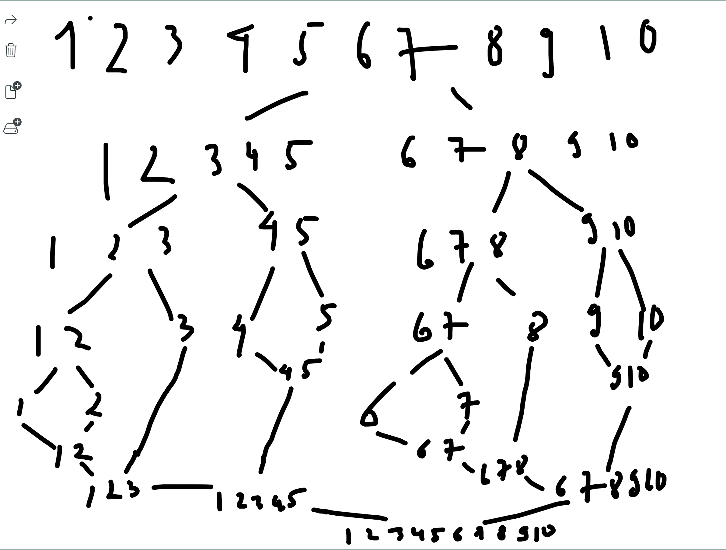

* QuickSort:

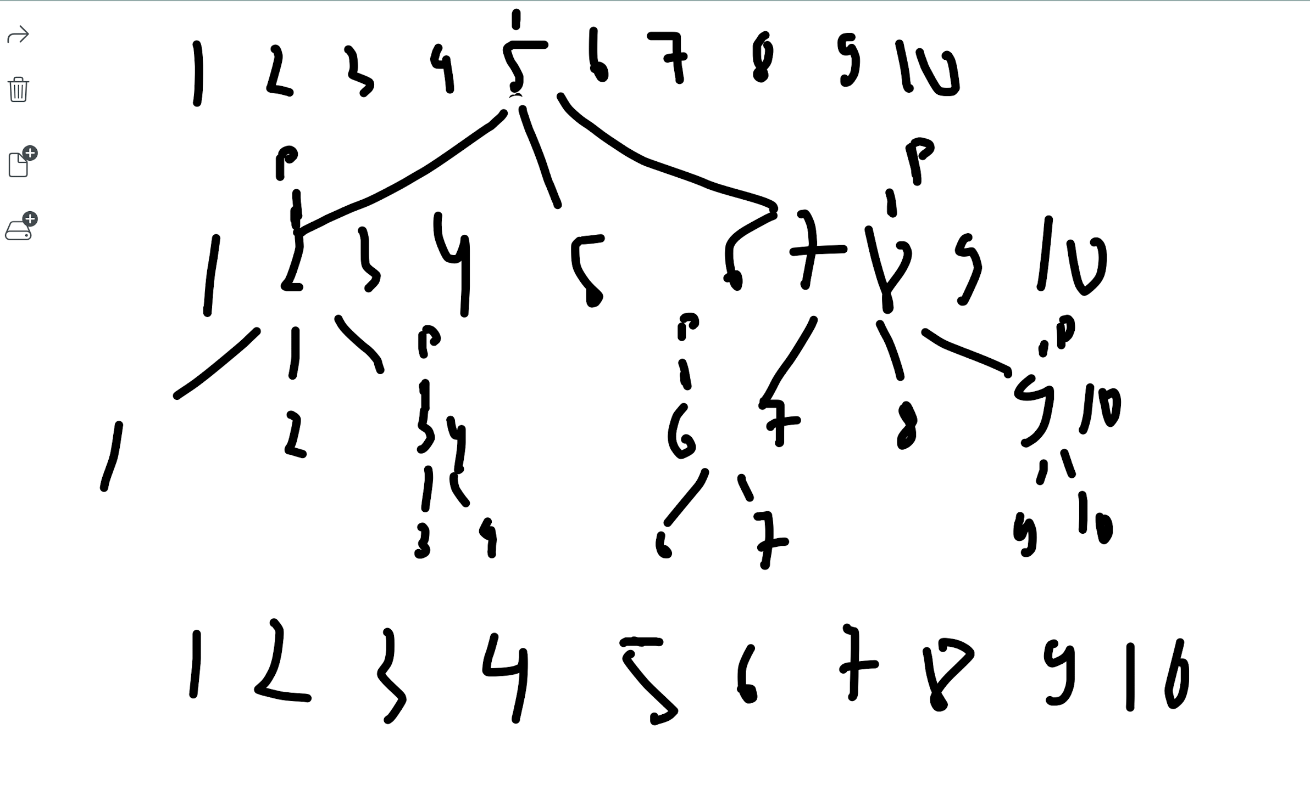

* HeapSort:

* RadixSort:

10, 9, 8, 7, 6, 5, 4, 3, 2, 1

* SelectionSort:

Step 0: 10 9 8 7 6 5 4 3 2 1

Step 1: 1 9 8 7 6 5 4 3 2 10

Step 2: 1 2 8 7 6 5 4 3 9 10

Step 3: 1 2 3 7 6 5 4 8 9 10

Step 4: 1 2 3 4 6 5 7 8 9 10

Step 5: 1 2 3 4 5 6 7 8 9 10

Step 6: 1 2 3 4 5 6 7 8 9 10

Step 7: 1 2 3 4 5 6 7 8 9 10

Step 8: 1 2 3 4 5 6 7 8 9 10

1 2 3 4 5 6 7 8 9 10

* InsertionSort:

Step 0: 10 9 8 7 6 5 4 3 2 1

Step 1: 9 10 8 7 6 5 4 3 2 1

Step 2: 8 9 10 7 6 5 4 3 2 1

Step 3: 7 8 9 10 6 5 4 3 2 1

Step 4: 6 7 8 9 10 5 4 3 2 1

Step 5: 5 6 7 8 9 10 4 3 2 1

Step 6: 4 5 6 7 8 9 10 3 2 1

Step 7: 3 4 5 6 7 8 9 10 2 1

Step 8: 2 3 4 5 6 7 8 9 10 1

1 2 3 4 5 6 7 8 9 10

* BubbleSort:

Step 0: 10 9 8 7 6 5 4 3 2 1

Step 1: 9 8 7 6 5 4 3 2 1 10

Step 2: 8 7 6 5 4 3 2 1 9 10

Step 3: 7 6 5 4 3 2 1 8 9 10

Step 4: 6 5 4 3 2 1 7 8 9 10

Step 5: 5 4 3 2 1 6 7 8 9 10

Step 6: 4 3 2 1 5 6 7 8 9 10

Step 7: 3 2 1 4 5 6 7 8 9 10

Step 8: 2 1 3 4 5 6 7 8 9 10

Step 9: 1 2 3 4 5 6 7 8 9 10

1 2 3 4 5 6 7 8 9 10

* MergeSort:

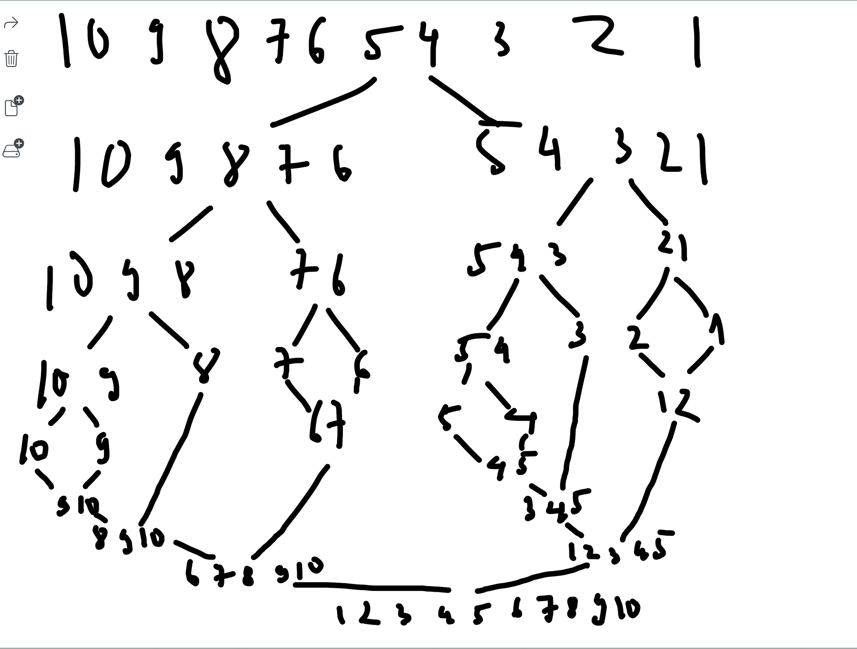

* QuickSort:

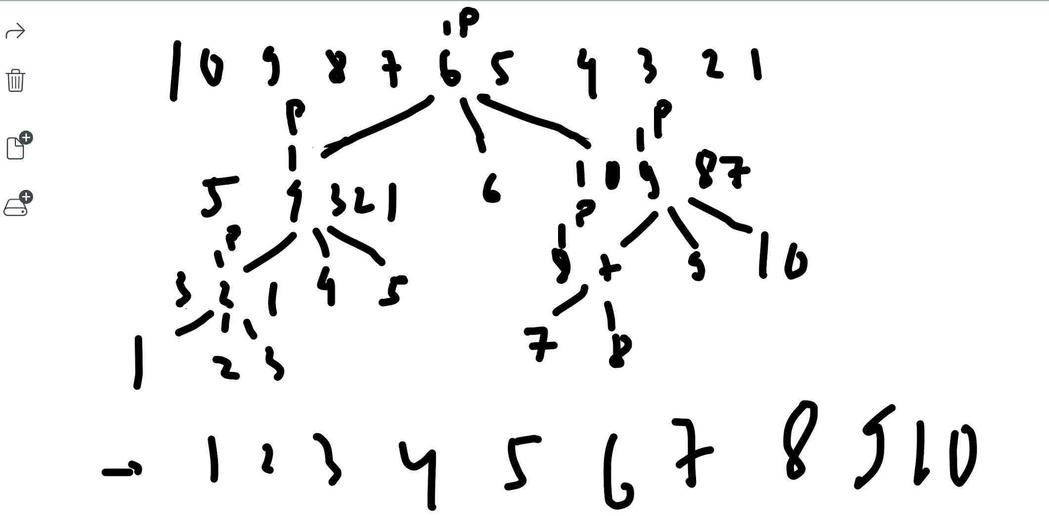

* HeapSort:

* RadixSort:

9, 10, 1, 2, 3, 4, 5, 6, 7, 8

* SelectionSort:

Step 0: 9 10 1 2 3 4 5 6 7 8

Step 1: 1 10 9 2 3 4 5 6 7 8

Step 2: 1 2 9 10 3 4 5 6 7 8

Step 3: 1 2 3 10 9 4 5 6 7 8

Step 4: 1 2 3 4 9 10 5 6 7 8

Step 5: 1 2 3 4 5 10 9 6 7 8

Step 6: 1 2 3 4 5 6 9 10 7 8

Step 7: 1 2 3 4 5 6 7 10 9 8

Step 8: 1 2 3 4 5 6 7 8 9 10

1 2 3 4 5 6 7 8 9 10

* InsertionSort:

Step 0: 9 10 1 2 3 4 5 6 7 8

Step 1: 9 10 1 2 3 4 5 6 7 8

Step 2: 1 9 10 2 3 4 5 6 7 8

Step 3: 1 2 9 10 3 4 5 6 7 8

Step 4: 1 2 3 9 10 4 5 6 7 8

Step 5: 1 2 3 4 9 10 5 6 7 8

Step 6: 1 2 3 4 5 9 10 6 7 8

Step 7: 1 2 3 4 5 6 9 10 7 8

Step 8: 1 2 3 4 5 6 7 9 10 8

1 2 3 4 5 6 7 8 9 10

* BubbleSort:

Step 0: 9 10 1 2 3 4 5 6 7 8

Step 1: 9 1 2 3 4 5 6 7 8 10

Step 2: 1 2 3 4 5 6 7 8 9 10

Step 3: 1 2 3 4 5 6 7 8 9 10

Step 4: 1 2 3 4 5 6 7 8 9 10

Step 5: 1 2 3 4 5 6 7 8 9 10

Step 6: 1 2 3 4 5 6 7 8 9 10

Step 7: 1 2 3 4 5 6 7 8 9 10

Step 8: 1 2 3 4 5 6 7 8 9 10

Step 9: 1 2 3 4 5 6 7 8 9 10

1 2 3 4 5 6 7 8 9 10

* MergeSort:

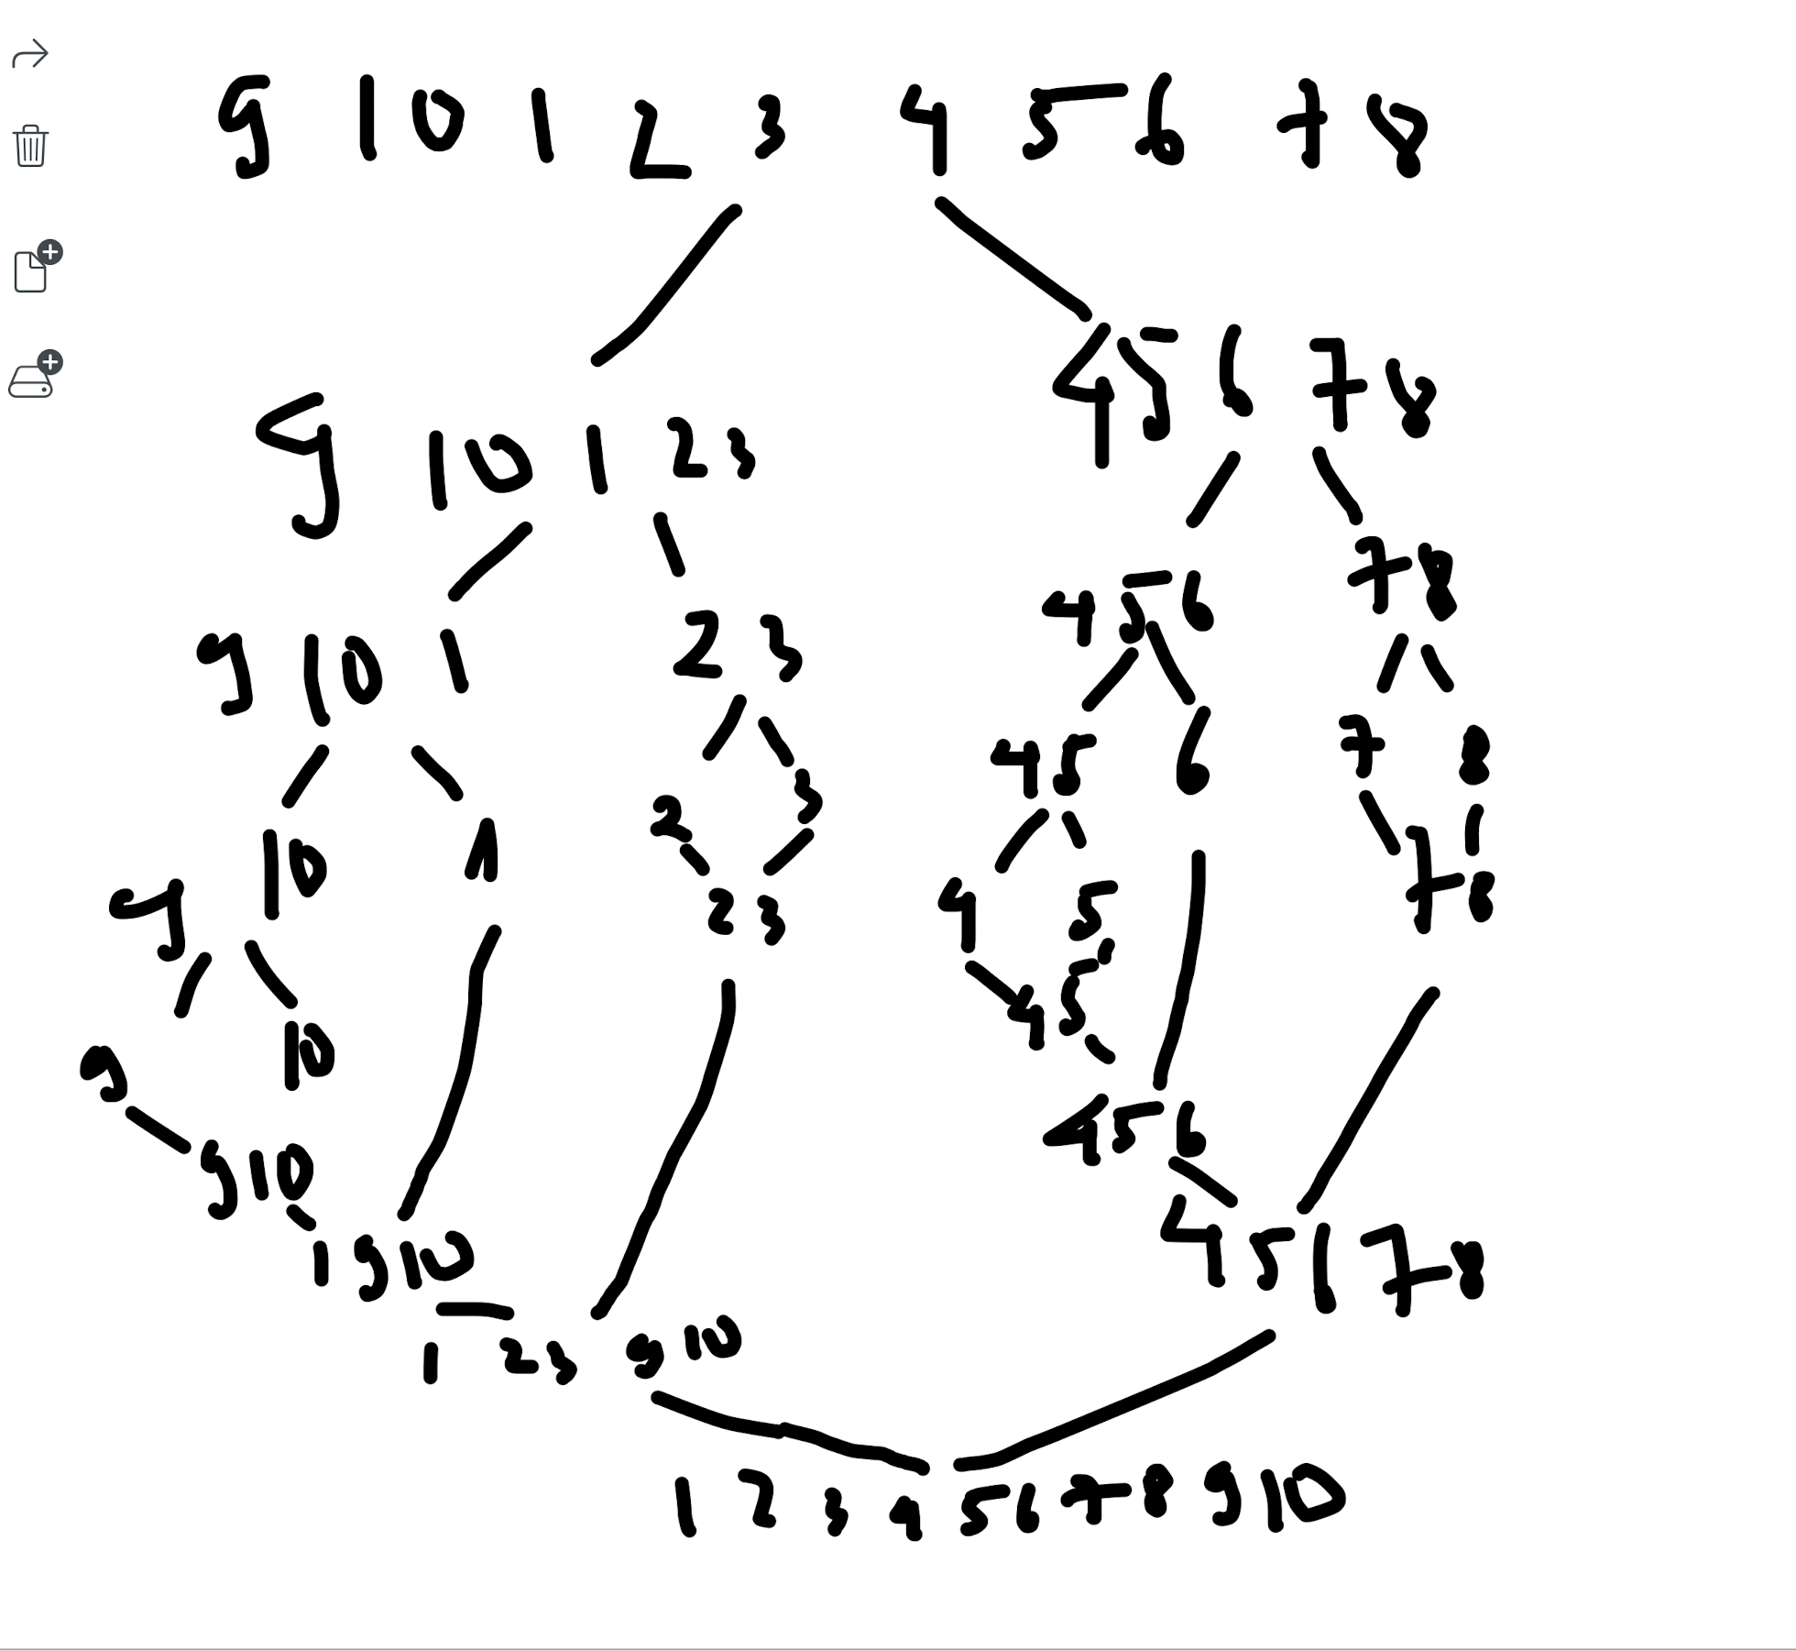

* QuickSort:

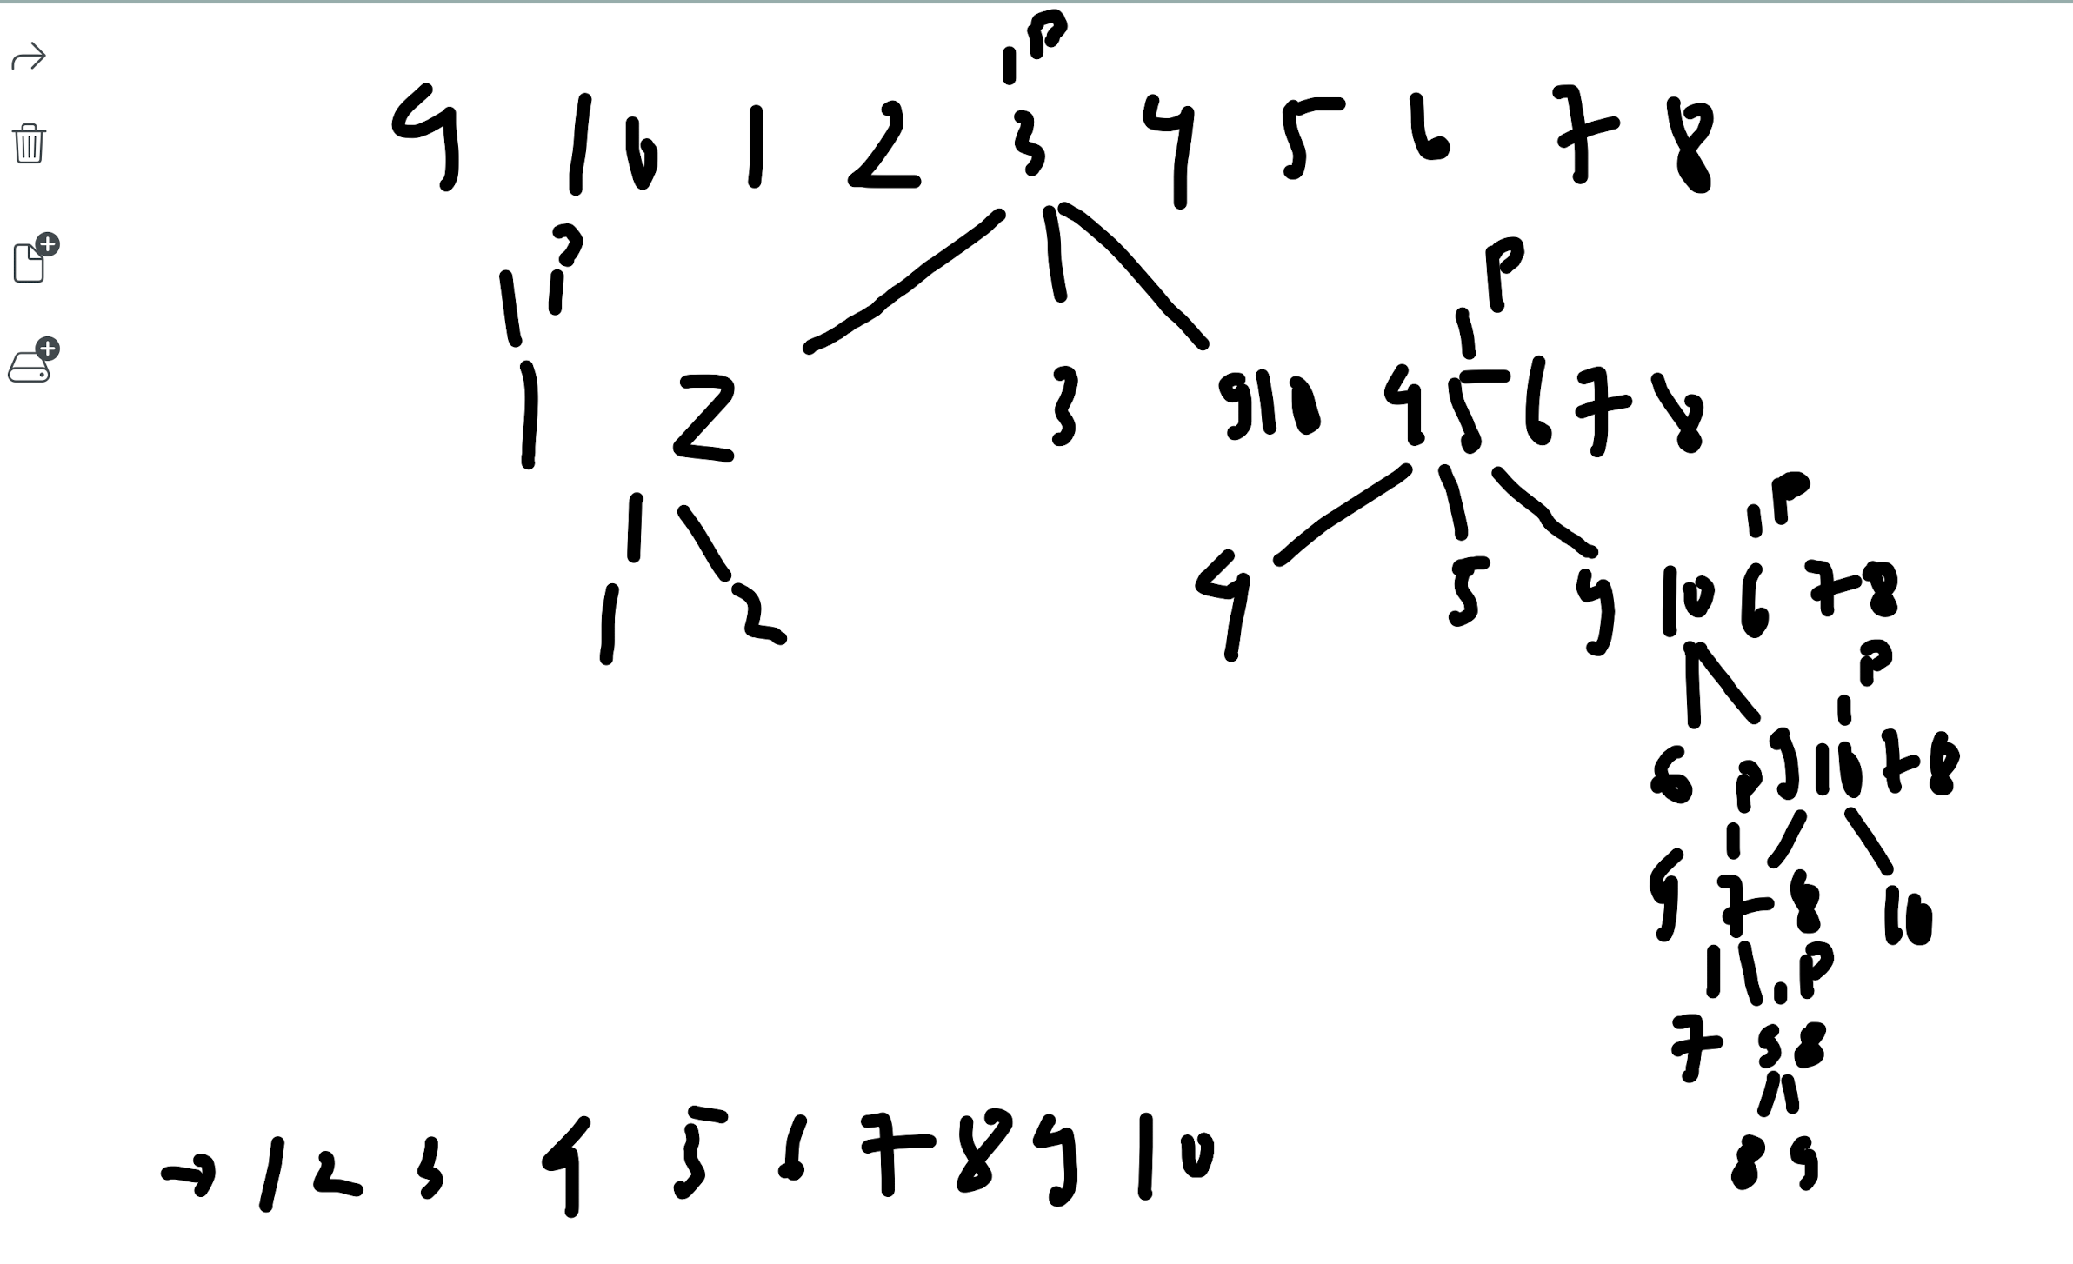

* HeapSort:

* RadixSort:

3, 4, 5, 6, 7, 8, 9, 10, 1, 2

* SelectionSort:

Step 0: 3 4 5 6 7 8 9 10 1 2

Step 1: 1 4 5 6 7 8 9 10 3 2

Step 2: 1 2 5 6 7 8 9 10 3 4

Step 3: 1 2 3 6 7 8 9 10 5 4

Step 4: 1 2 3 4 7 8 9 10 5 6

Step 5: 1 2 3 4 5 8 9 10 7 6

Step 6: 1 2 3 4 5 6 9 10 7 8

Step 7: 1 2 3 4 5 6 7 10 9 8

Step 8: 1 2 3 4 5 6 7 8 9 10

1 2 3 4 5 6 7 8 9 10

* InsertionSort:

Step 0: 3 4 5 6 7 8 9 10 1 2

Step 1: 3 4 5 6 7 8 9 10 1 2

Step 2: 3 4 5 6 7 8 9 10 1 2

Step 3: 3 4 5 6 7 8 9 10 1 2

Step 4: 3 4 5 6 7 8 9 10 1 2

Step 5: 3 4 5 6 7 8 9 10 1 2

Step 6: 3 4 5 6 7 8 9 10 1 2

Step 7: 3 4 5 6 7 8 9 10 1 2

Step 8: 1 3 4 5 6 7 8 9 10 2

1 2 3 4 5 6 7 8 9 10

* BubbleSort:

Step 0: 3 4 5 6 7 8 9 10 1 2

Step 1: 3 4 5 6 7 8 9 1 2 10

Step 2: 3 4 5 6 7 8 1 2 9 10

Step 3: 3 4 5 6 7 1 2 8 9 10

Step 4: 3 4 5 6 1 2 7 8 9 10

Step 5: 3 4 5 1 2 6 7 8 9 10

Step 6: 3 4 1 2 5 6 7 8 9 10

Step 7: 3 1 2 4 5 6 7 8 9 10

Step 8: 1 2 3 4 5 6 7 8 9 10

Step 9: 1 2 3 4 5 6 7 8 9 10

1 2 3 4 5 6 7 8 9 10

* MergeSort:

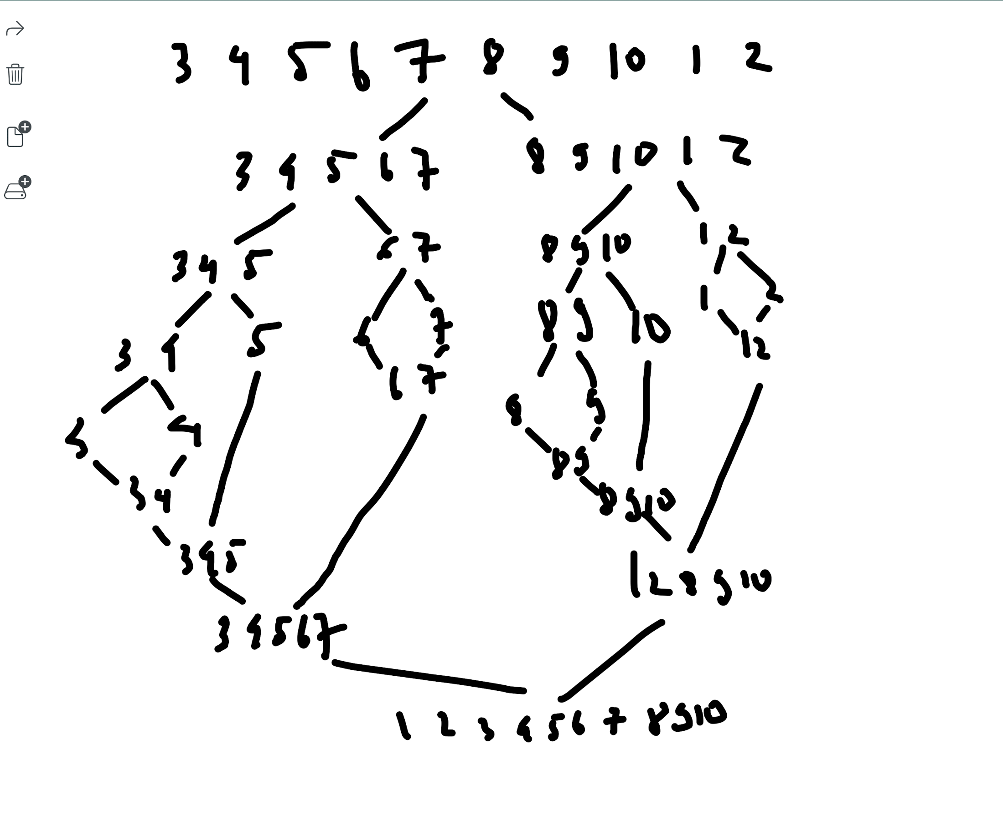

* QuickSort:

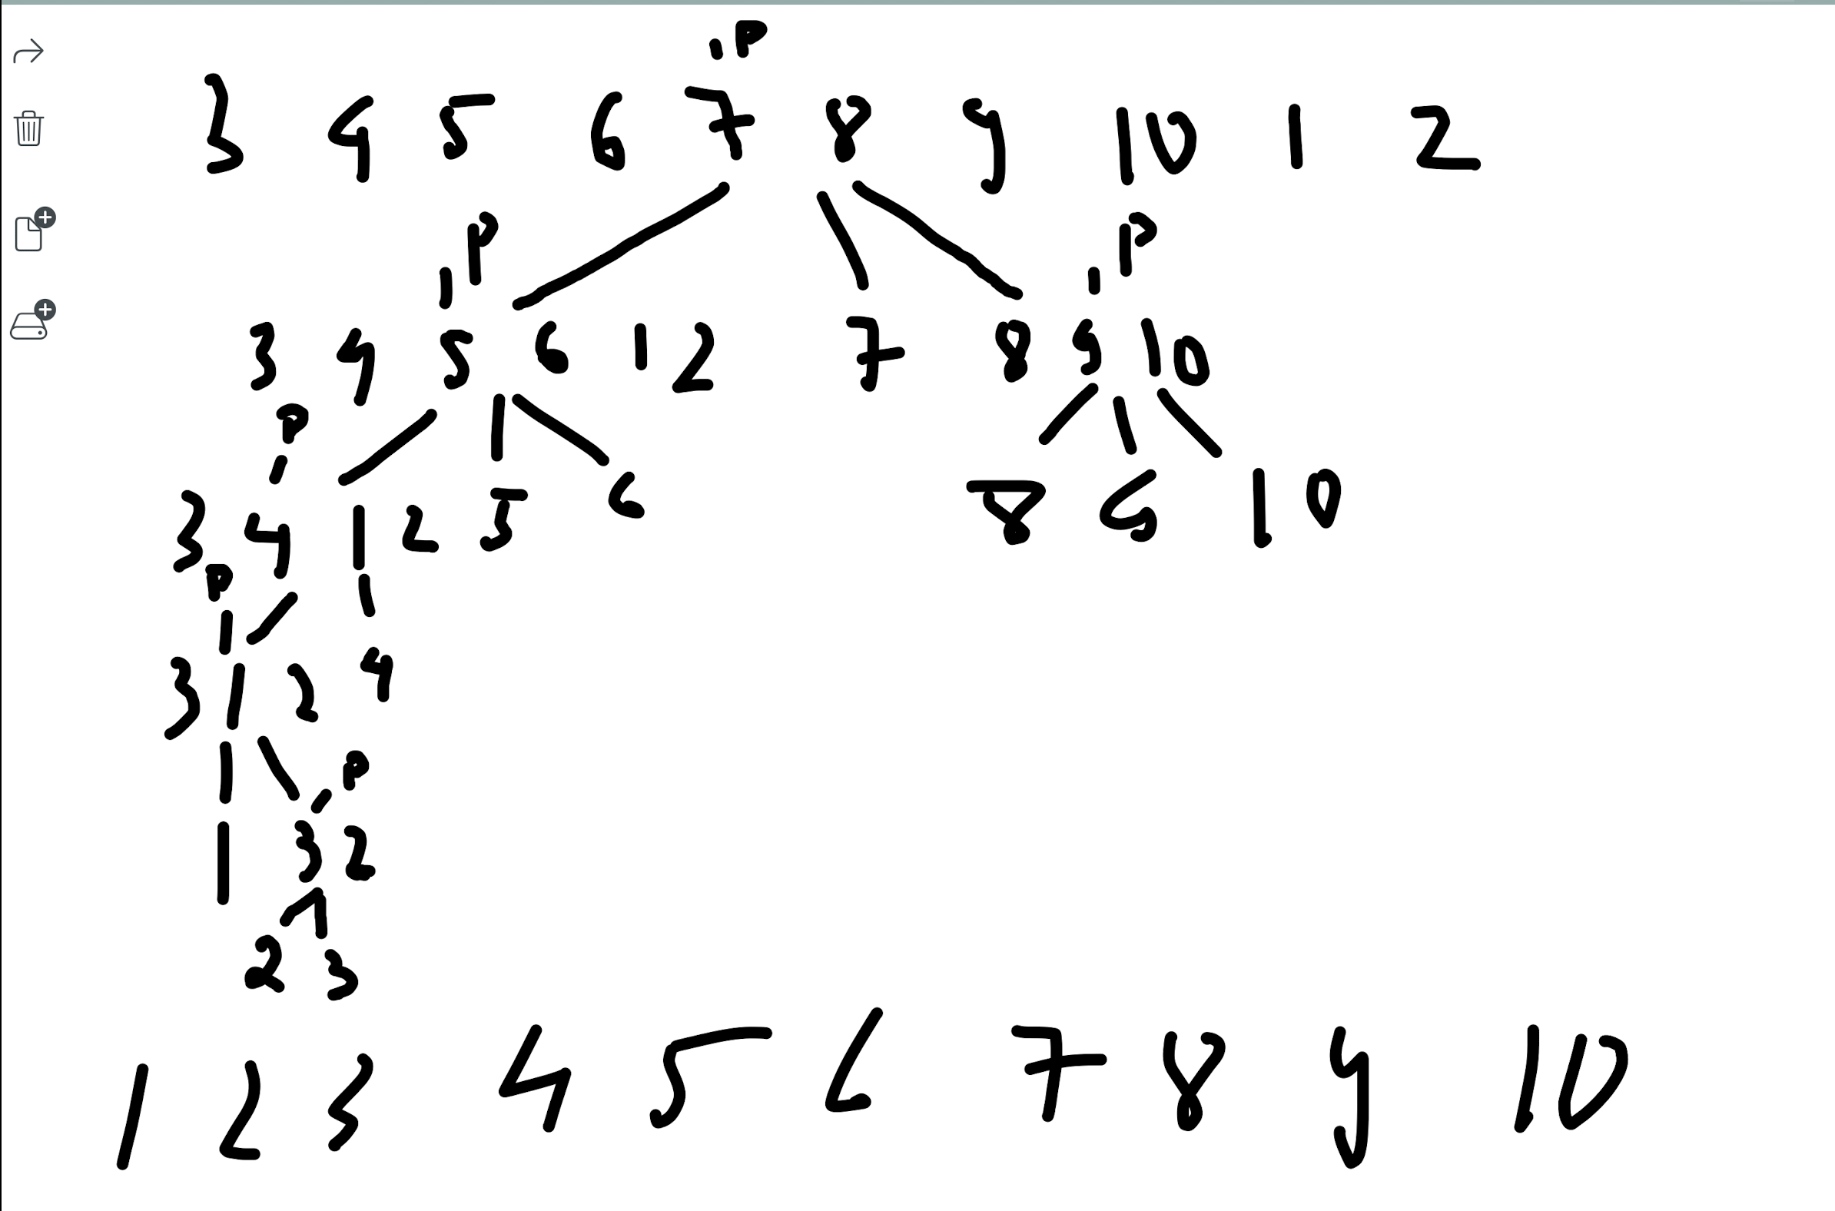

* HeapSort:

* RadixSort:

1. Write a program to sort (ascending sort) the list by following methods:
2. #include <iostream>  
     
   using namespace std ;  
     
   //print array  
   void printArr(int a[], int n) {  
    for(int i = 0 ; i<n ; i++) {  
    cout << a[i] << " " ;  
    }  
    cout << endl ;  
   }  
   //swap  
   void swap(int &a, int &b) {  
    int temp = a ;  
    a = b ;  
    b = temp ;  
   }  
     
   //selectionSort  
   void selectionSort(int a[], int n) {  
    for(int i = 0 ; i < n-1 ; i++){  
    cout << "Step " << i << ": " ;  
    printArr(a, n) ;  
    int minIndex = i ;  
    for(int j = i+1 ; j < n ; j++) {  
    if(a[j] < a[minIndex]) minIndex = j ;  
    }  
    swap(a[minIndex], a[i]) ;  
    }  
   }  
     
   // InsertionSort  
   void insertionSort(int a[], int n) {  
    for(int i = 1 ; i<n ; i++) {  
    cout << "Step " << i-1 << ": " ;  
    printArr(a, n) ;  
    int key = a[i] ;  
    int k = i - 1 ;  
    while(key < a[k] && k >= 0) {  
    a[k+1] = a[k] ;  
    k-- ;  
    }  
    a[k+1] = key ;  
    }  
   }  
     
   //BubbleSort  
   void bubbleSort(int a[], int n) {  
    for(int i = 0 ; i < n ; i++) {  
    cout << "Step " << i << ": " ;  
    printArr(a, n) ;  
    for(int j = 0; j < n - i ; j++) {  
    if(a[j] > a[j+1]) swap(a[j], a[j+1]) ;  
    }  
    }  
   }  
     
   //MergeSort  
     
   //merge  
   void merge(int arr[], int low, int mid, int height) {  
    // Tao 2 mang L[n1], R[n2]  
    int n1 = mid - low + 1 ;  
    int n2 = height - mid ;  
    int L[n1] ;  
    for(int i = 0 ; i<n1 ; i++) {  
    L[i] = arr[low+i] ;  
    }  
    int R[n2] ;  
    for(int i = 0 ; i<n2 ; i++) {  
    R[i] = arr[mid + 1 + i] ;  
    }  
     
    int i = 0, j = 0, k = low ;  
    while(i < n1 && j < n2) {  
    if(L[i] <= R[j]){  
    arr[k] = L[i] ;  
    i++ ;  
    }  
    else {  
    arr[k] = R[j];  
    j++ ;  
    }  
    k++ ;  
    }  
    //Mang L con phan tu  
    while(i<n1) {  
    arr[k] = L[i] ;  
    i++ ;  
    k++ ;  
    }  
    //Mang R con phan tu  
    while(j<n2) {  
    arr[k] = R[j] ;  
    k++ ;  
    j++ ;  
    }  
   }  
     
   //mergeSort  
   void mergeSort(int a[], int low, int height) {  
    if(low < height) {  
    int mid = low + (height-low) / 2 ;  
    mergeSort(a, low, mid) ;  
    mergeSort(a, mid+1, height) ;  
    merge(a, low, mid, height) ;  
    }  
   }  
     
     
   //QuickSort  
     
   void quickSort(int arr[], int low, int height) {  
    int i = low, j = height;  
    int tmp;  
    int pivot = arr[(low+height) / 2];  
    /* partition */  
    while (i <= j) {  
    while (arr[i] < pivot) i++;  
    while (arr[j] > pivot) j--;  
    if (i <= j) {  
    tmp = arr[i];  
    arr[i] = arr[j];  
    arr[j] = tmp;  
    i++;  
    j--;  
    }  
    };  
    //Recursion  
    if (low < j)  
    quickSort(arr, low, j);  
    if (i < height)  
    quickSort(arr, i, height);  
   }

* Heap sort:
* Radix sort: